Conveyor Motor Control - How the Ladder Logic Works (Rungs A –> D)
What this program is meant to do
This ladder logic controls a conveyor motor with:
- Start / Stop pushbuttons
- Emergency stop override (E-Stop)
- A seal-in latch (so the motor keeps running after you release Start)
- An optional AutoStop timer (stops the conveyor automatically after 30 seconds)
- No auto-restart after power loss (because the latch is non-retentive)

Signals / Tags used
Inputs
- Start_PB: Start button (momentary). TRUE when pressed.
- Stop_PB: Stop button. In this design it’s normalized: TRUE = healthy/not pressed (typical NC wiring).
- EStop_OK: Emergency stop healthy. Also normalized: TRUE = healthy (E-Stop not pressed).
- AutoStop_Enabled: Enables the 30s auto stop feature.
Internal bits
- Permissive_OK: “All safety conditions are good, we are allowed to run.”
- Run_Latch: Memory bit that holds the run command (seal-in).
Timer
- T_AutoStop (TON, 30s): Runs while the conveyor is running (and AutoStop_Enabled is TRUE).
  - T_AutoStop.Q becomes TRUE when 30 seconds has elapsed.
Output
- Motor_Run: Output coil that drives the motor starter/contactor.

Key assumption (important for safety logic)
This program assumes Stop_PB and EStop_OK are normalized:
- TRUE = healthy (circuit closed / not pressed)
- FALSE = not healthy (button pressed / circuit open)
This matches typical real-world NC safety wiring (fail-safe: a broken wire looks like a stop).

Rung-by-rung explanation
Rung A - Master Permissive (Safety Gate)
What it does:
This rung creates a single “permission to run” signal:
Permissive_OK = EStop_OK AND Stop_PB
So:
- If E-Stop is pressed -> EStop_OK = FALSE -> Permissive_OK = FALSE
- If Stop is pressed -> Stop_PB = FALSE -> Permissive_OK = FALSE
- Only when both are healthy does Permissive_OK become TRUE
Think of this as the main safety gate that everything else must pass through.

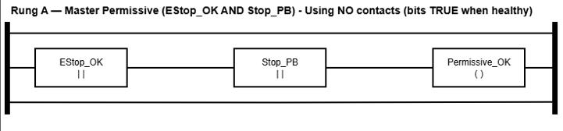

Rung B - Seal-in Latch with AutoStop Cutout (Platform-agnostic)
What it does:
This rung “remembers” the Start button press and keeps the conveyor running:
Run_Latch = Permissive_OK AND (Start_PB OR Run_Latch) AND NOT T_AutoStop.Q
Breakdown:
- Permissive_OK must be TRUE (safety is OK)
- (Start_PB OR Run_Latch) is the seal-in logic:
  - Start gives an initial TRUE
  - Then Run_Latch keeps itself TRUE after you release Start
- NOT T_AutoStop.Q is the auto-stop cutout:
  - Once the timer is “done” (Q = TRUE), this becomes FALSE, and the latch drops.
Why this design is strong:
- It doesn’t rely on special “reset coils” or scan-order quirks.
- It’s easy to reason about and works on basically any PLC ladder platform.
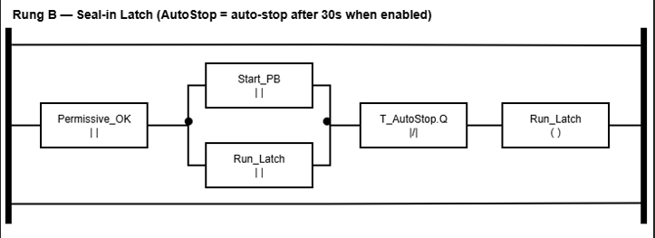

Rung C - AutoStop Timer (TON 30s)
What it does:
This rung runs the timer only while:
- the conveyor is latched on, and
- auto-stop is enabled
T_AutoStop.IN = Run_Latch AND AutoStop_Enabled
PT = 30 seconds
So:
- If AutoStop_Enabled is FALSE, the timer never runs.
- If the motor stops (Run_Latch goes FALSE), the timer resets (as TON timers do).
After 30 seconds of continuous running, T_AutoStop.Q becomes TRUE.
That TRUE is then used in Rung B to cut the latch.

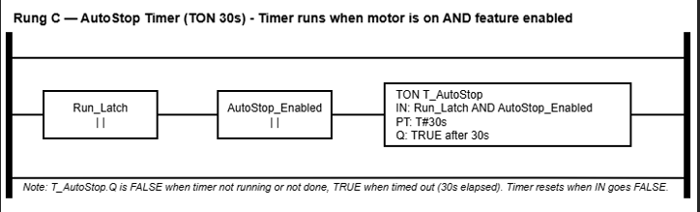

Rung D - Motor Output (Final Gate)
What it does:
This rung drives the real motor output:
Motor_Run = Run_Latch AND Permissive_OK
So even if Run_Latch was somehow TRUE, the motor still cannot run unless Permissive_OK is TRUE.
This is a good safety habit: safety conditions should directly gate the final output.
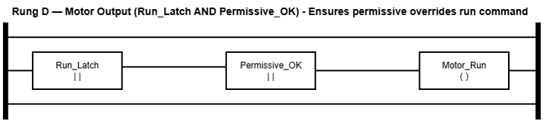

What happens in real life (quick scenarios)
Normal start
- E-Stop healthy, Stop not pressed -> Permissive_OK = TRUE
- Press Start -> Run_Latch turns TRUE
- Release Start -> Run_Latch stays TRUE (seal-in)
- Motor runs because Motor_Run = TRUE
Press Stop
- Stop makes Stop_PB = FALSE -> Permissive_OK = FALSE
- That immediately forces:
  - Run_Latch to drop (because Permissive_OK is required in Rung B)
  - Motor_Run to drop (because Permissive_OK is required in Rung D)
Press E-Stop
Same idea as Stop, except it’s the emergency channel:
- EStop_OK = FALSE -> motor drops immediately
AutoStop enabled
- Timer runs while running
- After 30 seconds: T_AutoStop.Q = TRUE
- That makes NOT T_AutoStop.Q = FALSE -> latch drops -> motor stops
Power loss / PLC restart
Because Run_Latch is non-retentive, it does not come back TRUE after power returns.
So the conveyor will not restart automatically, the operator must press Start again.

Why this (and common mistakes avoided)
- Safety inputs are treated as permissions (healthy = TRUE)
- Motor output is always gated by safety (Permissive_OK)
- Seal-in latch is implemented clearly and safely
- AutoStop is optional, and implemented in a platform-agnostic way (no set/reset dominance issues)
- No auto-restart after power loss
